Symposium

Thursday 25 Mai l 2017

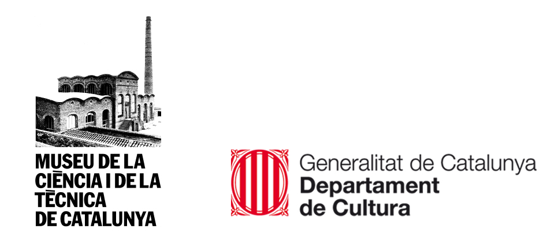

PROGRAM

08.45-09.15h Lliurament d’acreditacions

09.15-10.00h Symposium Opening lecture by the director of the Museu Nacional de la Ciència i de la Tècnica de Catalunya (mNACTEC), Jaume Perarnau.

Inaugural Conference i “Vision and development of the network of the Sistema Territorial del mNACTEC”. Eusebi Casanelles, Industrial Engineer mNACTEC past director from 1983 to 2013.

10.00-10.45h “The Museum of Science and Industry and the Science Museum Group”.
Sally MacDonald, director del Museum of Science and Industry a Manchester (England).

10.45-11.15h Coffe Break

11.15-12.00h "An integrated approach to the conservation, study and valorisation of
technical heritage: the case of the Museum Network of the Piraeus Cultural Foundation". Elia Vlachou, Museology and cultural maneger, past director Pyraeus industrial museum network. Greek Steam Institute (Greece).

12.00-12.45h “Networks of industrial Heritage Sites And Museums in the Rhein-Ruhr-Area in Germany". Walter Hauser, director of the LVR-Industriemuseums. Rheinisches Landesmuseum für Industrie (Germany).

12.45-13.15h "The Industrial Heritage Trail in the Ruhr and its aim for Regional
Development”. Marion Steiner, Route of the Ruhr (Germany)

13.15-13.45h Speaking time

13.45-15.45h Lunch

15.45-16.30h “Creating a network of industrial museums, Silesian experiences”.
Piotr Gerber, president eof the Foundation for the Preservation of Industrial Heritage Silesians Museums (Poland).

16.30-17.15h “The network of technical free countian museums”
Géraldine Balissat, responsable científique et d'operations. Musées
des techniques et cultures comtoises (França).

17.15-17.45h Torn de preguntes i cloenda.

18.00-19.00h Inauguració of the exhibition “Indústria. Territori. Identitat. The Industrial Heritage Route of the Ruhr”

Translation English –Catalan and Catalan –English

Museu Nacional de la Ciència i de la Tècnica de Catalunya (mNACTEC)
Rambla d’Ègara, 270.
08221 TERRASSA
Tel. 00 34 937 368 966
mnactec.cat

Registration
Registration free must be done before the day of Symposium throut internet

WEB
http://mnactec.cat/ca/activitat-detall/simposi-xarxa-de-museus-industrials-i-tecnics-deuropa

COL·LABORATION
Logo Ruta del Ruhr
ERIH
TICCIH
Industrial and Enginiering Commission Europa Nostra

